SSUSI PREP Data File Definition

APL Data Product Version = 0105

Change Log
Revision | Date | Change
1.5.0 | 3/28/08 | Added FirstYear, LastYear NetCDF fields
1.4.0 | 2/8/2007 | Scan_type changed to Scan_mode
1.3.0 | 1/11/2007 | Added Scan_Type field to easily discriminate between Full and Reduced Scans
1.2.0 | 7/19/2006 | Added data product version number to document.
1.1 | 4/19/2006 | Added nodal second
1.0 | 4/12/2006 | Initial version taken from SSUSI data formats document

SSUSI PREP Data File Definition 1
1 Introduction 2
2 Data Product Filename 2
3 Prep File 2
3.1 Format of Readout Information Record in Prep File. 3
3.2 Format of GWC Ephemeris Record in Prep File 4
3.3 Format of Z-Bits Ephemeris Record in Prep File. 5
3.4 SSUSI Sensor Data Record. 6
3.5 Sensor Data Packet Record. 7
3.6 Sensor Data Packet Header 7
3.7 Packet Data formats by Packet ID 8
3.7.1 Fill Packets 8
3.7.2 Full Image Scan 8
3.7.3 Reduced Scan Packets 11
3.7.4 Spectrograph mode 14
3.7.5 Maintenance Mode 16
3.7.6 Setup Mode 18
3.7.7 Test Mode 20
3.8 Supporting Data Prep File. 22

Introduction

This document describes the detailed formats of the data products that will be made by the UNIX based IDL and C++ processing system for the SSUSI instrument on DMSP spacecraft. This table is based on information from the old ADA based Software Design Document, but reflects changes made to the processing system.

We begin with a description of the Data Product file naming convention and then describe the data in order of processing, beginning with PREP files (which are reformatted raw data from the Raw Sensor Data Records received from the air force.). It then moves on to describe Level 1B, SDR, and various EDR data products.

Data Product Filename
- SSUSIFpp_Svaaaarbbb_yyyydoyREVoooooQOzz.mode_filetype: for all Prep files that encompass a single quarter orbit with a single scan overlap into adjoining quarter orbits
- where
- pp is the DMSP satellite number, with valid ranges of F01 through F20
- mode is the instrument mode. Allowable modes are as follows and are case sensitive:
- image - for imaging mode
- spect - for spectrograph mode
- maint – for maintenance mode
- test – for test mode
- S is the facility that generated the SSUSI data product. Allowable facilities are as follows and are case sensitive:
- A – for JHU/APL
- S – for Aerospace
- F – for AFWA
- aaaa is the 4 digit data product version number (this number combined with the revision number makes the data product file unique). "v" always precedes this indicating that this is a version number.
- bbb is the 3 digit data product revision number (this number combined with the version number makes the data product file unique). "r" always precedes this indicating that this is a revision number.
- yyyy is the 4 digit year. For multiple orbits, the first is start and the second is stop
- doy is the 3 digit day of the year.
- ooooo is the orbit number. For multiple orbits, the first is start and the second is stop
- zz is the quarter orbit designator number. Allowable choices are as follows and are case sensitive:
- NP – for North Polar
- SP – for Southern Polar
- DE – for Descending Equatorial
- AE – for Ascending Equatorial
- Filetype is the type of data product type in this case the type is PREP.

Prep File

This is an internal file produced by the BNSA software and its intent is to be ingested by the SSUSI Engineering POC and the APSB software. The data in this file contains compressed pixel data. It is unprocessed instrument data at full resolution, time-tagged, s/c location specified and tagged with a preliminary data quality flag. These files are constructed from DMSP “raw” files also called Raw Sensor Data Records (RSDRs) by the Data Reformatter in order to construct SSUSI Data product Files. The data is time ordered but stored in reverse chronological order which is how the RSDRs are received.

- per file

Data Item | Data Type | Field Size (Bytes) | Range or Nominal Value | Units
Header | N/A | 1637 | N/A | N/A

Format of Readout Information Record in Prep File.

There is only one Readout Information Record per Prep File.

Field | NetCDF Variable Name | Data Type | Bytes | Range | Content Notes
-Mission ID | Mission | string | 4 |  | 4 characters, e.g. “F16”
-Readout Rev | ReadoutRev | Integer | 4 | 1.. 4,294,967,295 | Satellite revolution number
-Nodal Long | NodalLong | integer | 4 | 0..3600 | East from Greenwich meridian for ascending nodal crossing of readout rev
-Nodal Julhr | NodalJulHr | integer | 4 | 0..34359738367 | AFGWC system time of readout rev nodal crossing relative to 0000Z on 12/31/67
-Nodal Day | NodalDay | integer | 4 | 1..31 | “
-Nodal Month | NodalMonth | integer | 4 | 1..12 | “
-Nodal Year | NodalYear | integer | 4 | 0..99 | “
-Nodal Time | NodalTime | integer | 4 | 0..2359 | 100x hour of day + minute of hour
*Nodal Second | NodalSecond | Integer | 2 | 0..59 | Seconds of the day
-Orbital Inclination | OrbitalInclination |  | 2 | TBD | Angle between the orbital plane and the equatorial plane. Range of 0 to pi. Stored as radians * TBD.
-Right Ascension of the Ascending Node | RAAN |  | 4 | TBD | Angle, measured at the center of the earth, from the vernal equinox to the ascending node. Range of 0 to 2 * pi. Stored as radians *TBD.
*RSDR Specification Version Number | RSDRSpec | integer | 2 | 8..6553 | Represents the version number taken from the DMSP Satellite RSDR File Format Specification. Stored as version number * 10 to allow for incrementing a version number by tenths.
-Minute Count (array of 2 or array of 8 bytes) | MinuteCount | byte | 8 No 8 byte integers | 1..34359738367 | minutes of data in this readout
-First Year | FirstYear | Integer | 4 | 2003-2100 | Year for latest record in Prep file
-First Julday | FirstJulDay | integer | 4 | 1..366 | Day of year for latest record in Prep file
-First Hour | FirstHour | integer | 4 | 0..23 | Hour of day for latest record in Prep file
-First Minute | FirstMinute | integer | 4 | 0..59 | Minute of hour for latest record in Prep file
-First Second | FirstSecond | integer | 4 | 0..59 | Second of minute for latest record in Prep file
-Last Year | LastYear | Integer | 4 | 2003-2100 | Year for latest record in Prep file
-Last Julday | LastJulDay | integer | 4 | 1..366 | Day of year for earliest record in Prep file
-Last Hour | LastHour | integer | 4 | 0..23 | Hour of day for earliest record in Prep file
-Last Minute | LastMinute | integer | 4 | 0..59 | Minute of hour for earliest record in Prep file
-Last Second | LastSecond | integer | 4 | 0..59 | Second of minute for earliest record in Prep file
-RSDR File Name | RSDRFilename | String | 60 |  | The name of the source RSDR file
-Prepfile Name | Filename | String | 60 |  | The name of this file
-R+ Number | R+Number | integer | 4 | 0 .. 14 | Readout rev number relative to beginning of satellite day (beginning at or west of 68.1W)
Total size |  |  | 130

Format of GWC Ephemeris Record in Prep File

There is one ephemeris record for all of the SSUSI sensor data records in a given scan. Therefore, for imaging mode, there is 22 seconds in a scan so there will be one ephemeris record associated with all 22 seconds of the SSUSI sensor data. For spectrograph mode, there is 3 seconds in a scan so there will be one ephemeris record associated with all 3 seconds of the SSUSI sensor data. For test, maintenance and setup modes, there is 1 second in a scan so there will be one ephemeris record associated with each 1 second of the SSUSI sensor data.

Field | NetCDF Variable Name | Data Type | Bytes | Range | Content
-Lat.,_1, Long._1 | Lat_1, Long_1, | Float | 2 x 4 | Float32
-Altitude_1 | Alt_1 | Integer | 4 | Integer32
-Julian_Day_1 | JulDay_1 | Integer | 4 | Integer32
-Time_1 | Time_1 | Integer | 4 | Integer32
-Lat._2, Long._2 | Lat_2, Long_2 | Float | 2 x4 | Float32
-Altitude_2 | Alt_2 | Integer | 4 | Integer32
-Julian_Day_2 | JulDay_2 | Integer | 4 | Integer32
-Time_2 | Time_2 | Integer | 4 | Integer32
*X1,Y1,Z1 | X1, Y1, Z1 | Float | 3 x 4 | Float32
*X2,Y2,Z2 | X2, Y2, Z2 | Float | 3 x 4 | Float32
-Sath_1, Sath_2 | Sath_1, Sath_2 | Float | 2 x 4 | Float32
-Data_Rev_1 | DataRev_1 | integer | 4 | Integer32
-Data_Rplus_1 | DataRplus_1 | integer | 4 | Integer32
-QO_1 | QO_1 | integer | 4 | Integer32 | Quarter orbit designator for each scan:  1 (equator to NP)  2 (SP to equator)  3 (equator to SP)  4 (NP to equator)
Total size |  |  | 84

Format of Z-Bits Ephemeris Record in Prep File.

There is one z-bit ephemeris record for all of the SSUSI sensor data records in a given scan. Therefore, for imaging mode, there is 22 seconds in a scan so there will be one z-bit ephemeris record associated with all 22 seconds of the SSUSI sensor data. For spectrograph mode, there is 3 seconds in a scan so there will be one z-bit ephemeris record associated with all 3 seconds of the SSUSI sensor data. For test, maintenance and setup modes, there is 1 second in a scan so there will be one z-bit ephemeris record associated with each 1 second of the SSUSI sensor data.

Field | NetCDF Variable Name | Data Type | Bytes | Range | Content
-Ephemeris Clock Time - Part 1 | EphemClockPt1 | integer | 2 | 0..8,191 | Time in elapsed seconds since 0000Z of day of year  (scaled integer when combined with part 2)
-Subpoint Longitude | SubpointLong | integer | 2 | 0..32,767 | Longitude of subsatellite point, WGS-72.  (scaled integer)
-Word pair ID 1 | WordPairID1 |  | 1 | 1 | ID field for 32-bit word pair.
-Subpoint Latitude | SubpointLat | integer | 2 | 0..16,383 | Geodetic latitude of subsatellite point, WGS-72.  (scaled integer)
-Cosine of Crossing Angle | CosCrossingAngle | integer | 2 | 0..8,191 | Cosine of crossing angle of subsatellite track with respect to local meridian (scaled integer)
-Word pair ID 2 | WordPairID2 |  | 1 | 2 | ID field for 32-bit word pair.
-Cosine of Solar Azimuth | CosSolarAzimuth | integer | 2 | 0..8191 | Azimuth of sun relative to direction of satellite flight  (scaled integer)
-Solar Elevation | SolarElevation | integer | 2 | 0..16,383 | Elevation of sun with respect to local orbit tangent plane  (scaled integer)
-Word pair ID 3 | WordPairID3 |  | 1 | 3 | ID field for 32-bit word pair.
-Height to earth radius ratio | HeightEarthRadiusRatio | integer | 2 | 0..8,191 | Altitude of spacecraft above subsatellite point at mean sea level (scaled integer)
-Ephemeris Clock Time - Part 2 | EphemClockPt2 | integer | 2 | 0..32,767 | Time in elapsed seconds since 0000Z of day of year  (scaled integer when combined with part 1)
-Word pair ID 4 | WordPairID4 |  | 1 | 4 | ID field for 32-bit word pair.
-Cosine of Lunar Azimuth | CosLunarAzimuth | byte | 1 | 0..127 | Azimuth of moon relative to direction of satellite flight
-Lunar Elevation | LunarElevation | integer | 2 | 0..4095 | Elevation of moon with respect to local orbit tangent plane
-Lunar Phase | LunarPhaseAngle | byte | 1 | 0..255 | Angle between lunar and solar pos. vectors in ECI frame
-Word pair ID 5 | WordPairID5 |  | 1 | 5 | ID field for 32-bit word pair
Total size |  |  | 25

SSUSI Sensor Data Record.

The data in this record comprises all of the SSUSI sensor packets (up to 22) within a given SSUSI instrument scan. The number of packets is determined by the instrument mode(s) within a given instrument scan period. Note that the instrument can change modes in the middle of a scan although it generally needs to go into setup mode prior to switching to the final mode.

Therefore, for imaging mode, there is 22 seconds in a scan so there will be one ephemeris record associated with all 22 seconds of the SSUSI sensor data, provided you are in imaging mode for the entire 22 seconds. For spectrograph mode, there is 3 seconds in a scan so there will be one ephemeris record associated with all 3 seconds of the SSUSI sensor data, provided you are in spectrograph mode for the entire 3 seconds. For test, maintenance and setup modes, there is 1 second in a scan so there will be one ephemeris record associated with each 1 second of the SSUSI sensor data.

Note: An existing SSUSI Sensor Data Record will be completed for the following reasons:

- The SSUSI instrument was in the same mode for the entire duration of the scan. This is a normal termination.
- The SSUSI instrument changed modes within a scan. In this case, a SSUSI sensor data record will be output for the original mode, containing all of the sensor data packets that occurred while in the original mode. Then, an additional SSUSI sensor data record will be output for the new mode containing all of the sensor data packets for that instrument mode.

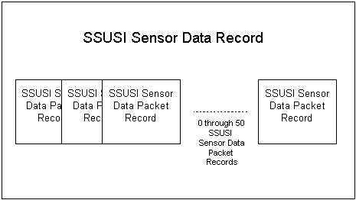

Sensor Data Packet Record.
Consists of one second of SSUSI sensor data, or rather one SSUSI sensor packet. There are 51 different types of SSUSI sensor packets numbered 0 through 50. Each Sensor Data Packet Record consists of a single SSUSI Sensor Data Packet Header and a single SSUSI Sensor Packet.

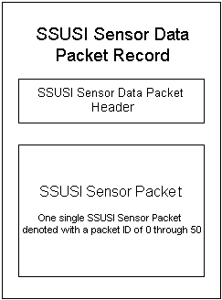

Sensor Data Packet Header

This appears once per sensor data packet record which occurs for every single packet of SSUSI sensor data at a frequency of once every second.

Field | NetCDF Variable Name | Data Type | Bytes | Range | Content
-OLS sync code | OLSSyncCode | byte | 5 | 23378884798 only | OLS message sync code
-OLS time | OLSTime | integer | 4 | 0..100,000,000 | Natural32
-Packet count | PacketCount | byte | 1 | 0..63 | Sequence of packet in readout
-Packet ID | PacketID | byte | 1 | 1 .. 150 | Flags Fill Packet when ID = 0 or  when 51 < ID < 100
Imaging scan mode | Scan_Mode | Char | 1 | “Full” or “Reduced” | This field occurs only in imaging mode data.
Lat_1sec | Lat_1sec | Int | 4 | -9000…9000
Long_1sec | Long_1sec | Int | 4 | 0000..360000
Alt_1sec | Alt_1sec | Int | 4 | 40000..50000
Total size |  |  | 23

Packet Data formats by Packet ID

Fill Packets
Format of Fill Packet Record in Prep File; Packet ID = 0

Field | NetCDF Variable Name | Data Type | Bytes | Range | Content
Sensor data packet header |  | N/A | 11 | N/A
data bits | DataBits | byte | 475 | 0 | All 3796 data bits set to 0 for fill packet.
Total size |  |  | 486

Full Image Scan

Format of First Scan Image Mode Record in Prep File; Packet ID = 1 through 21

Field | NetCDF Variable Name | Data Type | Bytes | Range | Content
Sensor data packet header |  | N/A | 11 | N/A
Photometer 427 count | Photometer427Count | Array of long (expand to a long) | 4 * 22 with 22nd index from Last Scan Image Mode, Packet ID 22 | 0..4,194,303
Photometer 629, 630 count | Photometer629Count  Photometer630Count | Array of long (expand to a long) | 2 x 4 * 22 with 22nd index from Last Scan Image Mode, Packet ID 22 | 0..2,097,151
Image Pixel Data | PixelData1 | Array of byte | 622 * 21 | 0..63 | 622 Full scan pixels
Total size |  |  | 645

Format of Last Scan Image Mode Record in Prep File; Packet ID = 22

Field | NetCDF Variable Name | Data Type | Bytes | Range | Content
Sensor data packet header |  | N/A | 11 | N/A
Photometer 427 count | Photometer427Count | Array of Integer (expand to a long) | 4 * 22 with 1st .. 21st index from First Scan Image Mode, Packet ID 1-21 | 0..4,194,303
Photometer 629, 630 count | Photometer629_630Count | Array of Integer (expand to a long) | 2 x 4 * 22 with 1st .. 21st index from First Scan Image Mode, Packet ID 1-21 | 0..2,097,151
Image Pixel Data | PixelData2 | byte | 378 | 0..63 | Full scan pixels
Detector Processing Ratio | DetectorRatio | byte | 180 | 0..63 | Full scan pixels
Pulse Height Data | PulseHeightData | Integer | 3 x 2
Flight Software Version Number | Flight_SW_Version | byte | 1
SSUSI Color Table Version Number | Flight_SW_ColorTable_Version | byte | 1
427, 629, 630 Filter Heater On | Filter427Heater  Filter629Heater  Filter630Heater | byte | 3 x 1
Dark, Background Count | DarkCount  BackgroundCount | integer | 2 x 2 | 0..65,535
Start position | MirrorStartPosition | integer | 2 | 0..4,095
Nadir Position | NadirPosition | integer | 2 | 0..4,095
Fault Status | FaultStatus | byte | 1 | 0, 1 | Fault status booleans
Previous Commands 1, 2 | PrevCommand1  PrevCommand2 | byte | 2 * 1 | 0 .. 255 | Last command from OLS
FIFO Status | FIFOStatus | byte | 1 | 0, 1 | FIFO status booleans
OLS reference count | OLSRefCount | byte | 1 | 0..255
SIS status | SISStatus | Integer | 2 | 0,1 | SSUSI status register booleans
Photometer status | PhotometerStatus | byte | 1 | 0,1 | Command mode, photom., SIS selection booleans
Detector configuration | DetectorConfig | byte | 1 | 0,1 | Booleans for control input to SIS FPE units.
Detector HVPS set | DetectorHighVoltage | byte | 1 | 0..255
427, 629, 630 Filter Set Temp | Filter427SetTemp  Filter629SetTemp  Filter630SetTemp | byte | 3 x 1 | 0..255
427, 629, 630 Filter Temp | Filter427Temp  Filter629Temp  Filter630Temp | byte | 3 x 1 | 0..255
PHVPS temp | PHVPSTemp | byte | 1 | 0..255
Primary, Backup illum. sensor | IllumSensor1  IllumSensor2 | byte | 2 x 1 | 0..255
427, 629, 630 Phot. HV | Photometer427HighVoltage  Photometer629HighVoltage  Photometer630HighVoltage | byte | 3 x 1 | 0..255
SIS radiator , Scan mirror temp | SISRadiatorTemp  ScanMirrorTemp | byte | 2 x 1 | 0..255
Primary , Secondary detector HV | Det1HighVoltage  Det2HighVoltage | byte | 2 x 1 | 0..255
Primary , Secondary FPE temp | FPE1Temp  FPE2Temp | byte | 2 x 1 | 0..255
SM I/O board temp | SMBoardTemp | byte | 1 | 0..255
Scan motor current | ScanMotorCurrent | byte | 1 | 0..255
Total size

So, if in Full Scan Imaging mode for the entire 22 seconds, the SSUSI Sensor Data Packet Record will be depicted as:

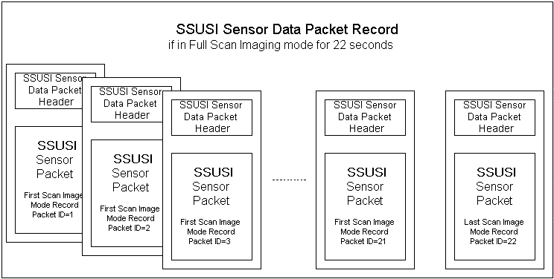

Reduced Scan Packets

Format of First Reduced Scan Mode Record in Prep File; Packet ID = 23 through 43

Field | NetCDF Variable Name | Data Type | Bytes | Range | Content
Sensor data packet header |  | N/A | 11 | N/A
-Photometer 427 count | Photometer427Count | Array of long | 4 * 22 with 22nd index from Last Scan Image Mode, Packet ID 44 | 0..4,194,303
-Photometer 629, 630 counts | Photometer629Count  Photometer630Count | Array of long | 2 x 4 * 22 with 22nd index from Last Scan Image Mode, Packet ID 44 | 0..2,097,151
-Image Pixel Data (533 counts) | PixelData1 | Array of byte | 533 * 21 | 0..127 | Reduced-scan pixels
Total size

Format of Last Reduced Scan Mode Record in Prep File; Packet ID = 44

Field | NetCDF Variable Name | Data Type | Bytes | Range | Content
Sensor data packet header |  | N/A | 11 | N/A
-Photometer 427 count | Photometer427Count | Array of long | 4 * 22 with 1st - 21nd index from first Scan Image Mode, Packet ID 23 - 43 | 0..4,194,303
-Photometer 629, 630 counts | Photometer629Count  Photometer630Count | Array of long | 2 x 4 * 22 with 1st - 21nd index from first Scan Image Mode, Packet ID 23 - 43 | 0..2,097,151
-Image Pixel Data | PixelData2 | byte | 327 | 0..127 | Reduced scan pixels
-Detector processing ratios | DetectorRatio | byte | 156 | 0..63 | 156 across-track scan steps
-Pulse Height data | PulseHeightData | integer | 2 x 15 | 0..1023 | Wedge, strip,. intermediate, other pulse height
-Flight Software Version Number | Flight_SW_Version | byte | 1
-SSUSI Color Table Version Number | Flight_SW_ColorTable_Version | byte | 1
-427,629,630 Filter Heater On | Filter427Heater  Filter629Heater  Filter630Heater | byte | 3 x 1
-Dark, Background Count | DarkCount  BackgroundCount | integer | 2 x 2 | 0..65,535
-Start position, nadir position | MirrorStartPosition  NadirPosition | integer | 2 x 2 | 0..4,095
-Fault Status | FaultStatus | byte | 1 | 0, 1 | Fault status booleans
-Previous Commands 1, 2 | PrevCommand1  PrevCommand2 | byte | 2 * 1 | 0..255 | Last command from OLS
-FIFO Status | FIFOStatus | byte | 1 | 0, 1 | FIFO status booleans
-OLS reference count | OLSRefCount | byte | 1 | 0..255
-SIS status | SISStatus | integer | 2 | 0,1 | SSUSI status register booleans
-Photometer status | PhotometerStatus | byte | 1 | 0,1 | Command mode, photom., SIS selection booleans
-Detector configuration | DetectorConfig | byte | 1 | 0,1 | Booleans for control input to SIS FPE units.
-Detector HVPS set | DetectorHighVoltage | byte | 1 | 0..255
-427,629,630 filter Set Temp | Filter427SetTemp  Filter629SetTemp  Filter630SetTemp | byte | 1 x 3 | 0..255
-427,629,630 filter Temp | Filter427Temp  Filter629Temp  Filter630Temp | byte | 1 x 3 | 0..255
-PHVPS temp | PHVPSTemp | byte | 1 | 0..255
-Primary, Backup illumination sensor | IllumSensor1  IllumSensor2 | byte | 1 x 2 | 0..255
-Photom. 427, 629, 630 HV | Photometer427HighVoltage  Photometer629HighVoltage  Photometer630HighVoltage | byte | 1 x 3 | 0..255
-SIS radiator, scan mirror temp | SISRadiatorTemp  ScanMirrorTemp | byte | 1 x 2 | 0..255
-Primary, secondary detector HV | Det1HighVoltage  Det2HighVoltage | byte | 1 x 2 | 0..255
-Primary, secondary FPE temp | FPE1Temp  FPE2Temp | byte | 1 x 2 | 0..255
-SM I/O board temp | SMBoardTemp | byte | 1 | 0..255
-Scan motor current | ScanMotorCurrent | byte | 1 | 0..255
Total size

So, if in Reduced Scan Imaging mode for the entire 22 seconds, the SSUSI Sensor Data Packet Record will be depicted as:

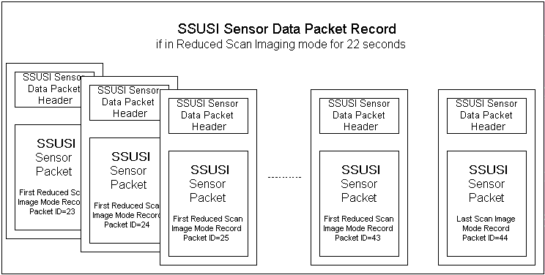

Spectrograph mode

Format of First Spectrograph Mode Record in Prep File; Packet ID = 45 or 46

Field | NetCDF Variable Name | Data Type | Bytes | Range | Content
Sensor data packet header |  | N/A | 11 | N/A
Photometer 427 count | Photomter427Count | long | 4 | 0..4,194,303
Photometer 629, 630 counts | Photometer629Count  Photometer630Count | long | 2 x 4 | 0..2,097,151
Spectrograph Data | PixelData1 | byte | 466 | 0..255 | 466 Spectrograph counts
Total size

Format of Last Spectrograph Mode Record in Prep File; Packet ID = 47

Field | NetCDF Variable Name | Data Type | Bytes | Range | Content
Sensor data packet header |  | N/A | 11 | N/A
Photometer 427 count | Photomter427Count | long | 4 | 0..4,194,303
Photometer 629, 630 counts | Photometer629Count  Photometer630Count | long | 2 x 4 | 0..2,097,151
Spectrograph Data | PixelData2 | byte | 412 | 0..255 | 412 Spectrograph counts
Flight Software Version Number | Flight_SW_Version | byte | 1
Pulse height data | PulseHeightData | integer | 3 x 2? | 0..1023 | Wedge, strip,. intermediate, other pulse height
Scan Mirror Position | MirrorPosition | integer | 2 | 0..4095
Detector input, output rate | DetInputRate  DetOutputRate | long | 2 x 4 | 0..4,294,967,295
Dark Count | DarkCount | integer | 2 | 0..65535
Fault Status | FaultStatus | byte | 1 | 0,1 | fault status booleans
Previous Commands 1, 2 | PrevCommand1  PrevCommand2 | byte | 2 x 1 | 0..255 | last command from OLS
FIFO Status | FIFOStatus | byte | 1 | 0,1 | FIFO status booleans
OLS reference count | OLSRefCount | byte | 1 | 0..255
SIS status | SISStatus | byte | 2 | 0,1 | SSUSI status register booleans
Photometer status | PhotometerStatus | byte | 1 | 0,1 | Command mode, photom., SIS selection booleans
Detector configuration | DetectorConfig | byte | 1 | 0,1 | Booleans for control input to SIS FPE units.
Detector HVPS set | DetectorHighVoltage | byte | 1 | 0..255
427,629,630 filter Set Temp | Filter427SetTemp  Filter629SetTemp  Filter630SetTemp | byte | 3 x 1 | 0..255
427,629,630 filter Temp | Filter427Temp  Filter629Temp  Filter630Temp | byte | 3 x 1 | 0..255
PHVPS temp | PHVPSTemp | byte | 1 | 0..255
Primary, Backup illumination sensor | IllumSensor1  IllumSensor2 | byte | 2 x 1 | 0..255
Photometer 427, 629, 630 HV | Photometer427HighVoltage  Photometer629HighVoltage  Photometer630HighVoltage | byte | 3 x 1 | 0..255
SIS radiator, scan mirror temp | SISRadiatorTemp  ScanMirrorTemp | byte | 2 x 1 | 0..255
Primary, secondary detector HV | Det1HighVoltage  Det2HighVoltage | byte | 2 x 1 | 0..255
Primary, secondary FPE temp | FPE1Temp  FPE2Temp | byte | 2 x 1 | 0..255
SM I/O board temp | SMBoardTemp | byte | 1 | 0..255
Scan motor current | ScanMotorCurrent | byte | 1 | 0..255
Total size

So, if in Spectrograph mode for the entire 3 seconds, the SSUSI Sensor Data Packet Record will be depicted as:

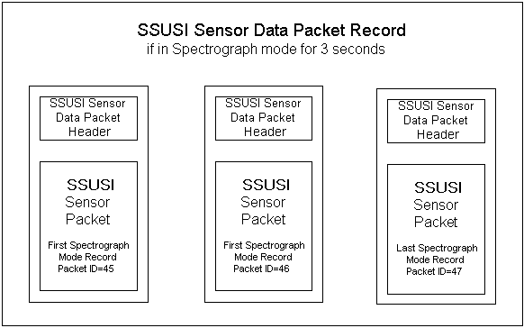

Maintenance Mode
Format of Maintenance Mode Records in Prep File; Packet ID = 48

Field | NetCDF Variable Name | Data Type | Bytes | Range | Content
Sensor data packet header |  | N/A | 11 | N/A
Photometer 427 count | Photometer427Count | long | 4 | 0..4,194,303
Photometer 629, 630 counts | Photometer629Count  Photometer630Count | long | 2 x 4 | 0..2,097,151
Source, Dest, Count, & Increment Registers | SourceRegister  DestRegister  CountRegister  IncrementRegister | integer | 4 x 2 | 0..65,535
Memory Page | MemoryPage | byte | 1 | 0..255
Memory Address | MemoryAddress | Integer | 2 | 0..65,535
Memory Data Dump | MemoryDataDump | byte | 423 | 0..255 | dump 423,
Upload Checksum | UploadChecksum | integer | 2
Fault Status | FaultStatus | byte | 1 | 0,1 | fault status booleans
Previous Commands 1, 2 | PrevCommand1  PrevCommand2 | byte | 2 x 1 | 0..255 | last command from OLS
FIFO Status | FIFOStatus | byte | 1 | 0,1 | FIFO status booleans
OLS reference count | OLSRefCount | byte | 1 | 0..255
SIS status | SISStatus | integer | 2 | 0,1 | SSUSI status register booleans
Photometer status | PhotometerStatus | byte | 1 | 0,1 | Command mode, photom., SIS selection booleans
Detector configuration | DetConfig | byte | 1 | 0,1 | Booleans for control input to SIS FPE units.
Detector HVPS set | DetHighVoltage | byte | 1 | 0..255
427,629,630 filter Set Temp | Filter427SetTemp  Filter629SetTemp  Filter630SetTemp | byte | 3 x 1 | 0..255
427,629,630 filter Temp | Filter427Temp  Filter629Temp  Filter630Temp | byte | 3 x 1 | 0..255
PHVPS temp | PHVPSTemp | byte | 1 | 0..255
Primary, Backup illumination sensor | IllumSensor1  IllumSensor2 | byte | 2 x 1 | 0..255
Photometer 427, 629, 630 HV | Photometer427HighVoltage  Photometer629HighVoltage  Photometer630HighVoltage | byte | 3 x 1 | 0..255
SIS radiator, scan mirror temp | SISRadiatorTemp  ScanMirrorTemp | byte | 2 x 1 | 0..255
Primary, secondary detector HV | Det1HighVoltage  Det2HighVoltage | byte | 2 x 1 | 0..255
Primary, secondary FPE temp | FPE1Temp  FPE2Temp | byte | 2 x 1 | 0..255
SM I/O board temp | SMBoardTemp | byte | 1 | 0..255
Scan motor current | ScanMotorCurrent | byte | 1 | 0..255
Total size

So, in Maintenance mode, the SSUSI Sensor Data Packet Record will be depicted as:

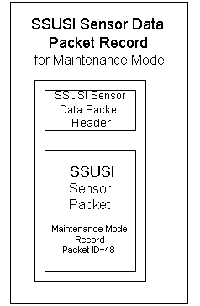

Setup Mode
Format of Setup Mode Records in Prep File; Packet ID = 49

Field | NetCDF Variable Name | Data Type | Bytes | Range | Content
Sensor data packet header |  | N/A | 11 | N/A
Photometer 427 count | Photometer427Count | long | 4 | 0..4,194,303
Photometer 629, 630 counts | Photmoter629Count  Photometer630Count | long | 2 x 4 | 0..2,097,151
Source, Dest, Count, & Increment Registers | SouceRegister  DestRegister  CountRegister  IncrementRegister | integer | 4 x 2 | 0..65,535
Memory Page | MemoryPage | byte | 1 | 0..255
Memory Address | MemoryAddress | integer | 2 | 0..65,535
Memory Data Dump | MemoryDataDump | byte | 418 | 0..255 | Dump 418
Flight Software Version Number | Flight_SW_Version | byte | 1
Scan Mirror Position | MirrorPositoin | integer | 2
Detector Input Rate | DetInputRate | integer | 4 | 0..4,294,967,295
Fault Status | FaultStatus | byte | 1 | 0,1 | fault status booleans
Previous Commands 1, 2 | PrevCommand1  PrevCommand2 | byte | 2 x 1 | 0..255 | last command from OLS
FIFO Status | FIFOStatus | byte | 1 | 0,1 | FIFO status booleans
OLS reference count | OLSRefCount | byte | 1 | 0..255
SIS status | SISStatus | integer | 2 | 0,1 | SSUSI status register booleans
Photometer status | PhotometerStatus | byte | 1 | 0,1 | Command mode, photom., SIS selection booleans
Detector configuration | DetConfig | byte | 1 | 0,1 | Booleans for control input to SIS FPE units.
Detector HVPS set | DetHVPS | byte | 1 | 0..255
427,629,630 filter Set Temp | Filter427SetTemp  Filter629SetTemp  Filter630SetTemp | byte | 3 x 1 | 0..255
427,629,630 filter Temp | Filter427Temp  Filter629Temp  Filter630Temp | byte | 3 x 1 | 0..255
PHVPS temp | PHVPSTemp | byte | 1 | 0..255
Primary, Backup illumination sensor | IllumSensor1  IllumSensor2 | byte | 2 x 1 | 0..255
Photometer 427, 629, 630 HV | Photometer427HighVoltage  Photometer629HighVoltage  Photometer630HighVoltage | byte | 3 x 1 | 0..255
SIS radiator, scan mirror temp | SISRadiatorTemp  ScanMirrorTemp | byte | 2 x 1 | 0..255
Primary, secondary detector HV | Det1HighVoltage  Det2HighVoltage | byte | 2 x 1 | 0..255
Primary, secondary FPE temp | FPE1Temp  FPE2Temp | byte | 2 x 1 | 0..255
SM I/O board temp | SMBoardTemp | byte | 1 | 0..255
Scan motor current | ScanMotorCurrent | byte | 1 | 0..255
Total size

So, in Setup mode, the SSUSI Sensor Data Packet Record will be depicted as:

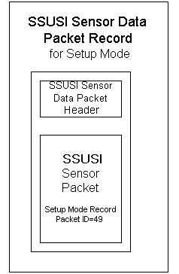

Test Mode
Format of Test Mode Records in Prep File; Packet ID = 50

Field | NetCDF Variable Name | Data Type | Bytes | Range | Content
Sensor data packet header |  | N/A | 11 | N/A
Photometer 427 count | Photometer427Count | long | 4 | 0..4,194,303
Photometer 629, 630 counts | Photometer629Count  Photometer630Count | long | 2 x 4 | 0..2,097,151
Flight Software Version Number | Flight_SW_Version | byte | 1 | 0..15 | An abbreviated flight s/w version number since there is only room for 4 bits in the sensor telemetry data. All other instrument modes have 8 bits in the sensor telemetry data.
DPU Test results | DPUTestResult | byte | 16 | 0..255
Pulse Height data | PulseHeightData | long | 333 x 2 | 0.. 4,194,303
Detector input rate | DetInputRate | integer | 4 | 0..65,535
Fault Status | FaultStatus | byte | 1 | 0,1 | fault status booleans
Previous Commands 1, 2 | PrevCommand1  PrevCommand2 | byte | 2 x 1 | 0..255 | last command from OLS
FIFO Status | FIFOStatus | byte | 1 | 0,1 | FIFO status booleans
OLS reference count | OLSRefCount | byte | 1 | 0..255
SIS status | SISStatus | integer | 2 | 0,1 | SSUSI status register booleans
Photometer status | PhotometerStatus | byte | 1 | 0,1 | Command mode, photom., SIS selection booleans
Detector configuration | DetConfig | byte | 1 | 0,1 | Booleans for control input to SIS FPE units.
Detector HVPS set | DetHVPSSet | byte | 1 | 0..255
427,629,630 filter Set Temp | Filter427SetTemp  Filter629SetTemp  Filter630SetTemp | byte | 3 x 1 | 0..255
427,629,630 filter Temp | Filter427Temp  Filter629Temp  Filter630Temp | byte | 3 x 1 | 0..255
PHVPS temp | PHVPSTemp | byte | 1 | 0..255
Primary, Backup illumination sensor | IllumSensor1  IllumSensor2 | byte | 2 x 1 | 0..255
SIS radiator, scan mirror temp | SISRadiatorTemp  ScanMirrorTemp | byte | 2 x 1 | 0..255
Primary, secondary detector HV | Det1HighVoltage  Det2HighVoltage | byte | 2 x 1 | 0..255
Primary, secondary FPE temp | FPE1Temp  FPE2Temp | byte | 2 x 1 | 0..255
SM I/O board temp | SMBoardTemp | byte | 1 | 0..255
Scan motor current | ScanMotorCurrent | byte | 1 | 0..255
Total size

So, when in Test Mode, SSUSI Sensor Data Packet Record will be depicted as:

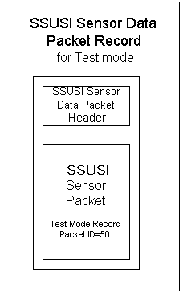

Supporting Data Prep File.
This is an ancilliary file that will be implemented after launch and will be propagated as a function of time, in reverse chronological order with the ephemeris and z-bit records at a 1 second resolution.

Data Item | Data Type | Field Size (Bytes) | Range or Nominal Value | Units
Header | N/A | 1637 | N/A | N/A
GWC Ephemeris Record | N/A |  | N/A | N/A
Z-Bits Ephemeris Record | N/A |  | N/A | N/A

Total Prep Data file:
Header: 1637 bytes
Data per scan: 57 bytes * (min. orbit / sec. Scan) = bytes
Imaging data per scan: 81,748 bytes * (min. orbit / sec. Scan) = bytes
Total: bytes = ~ Mbytes per orbit



